**30-01-2024**

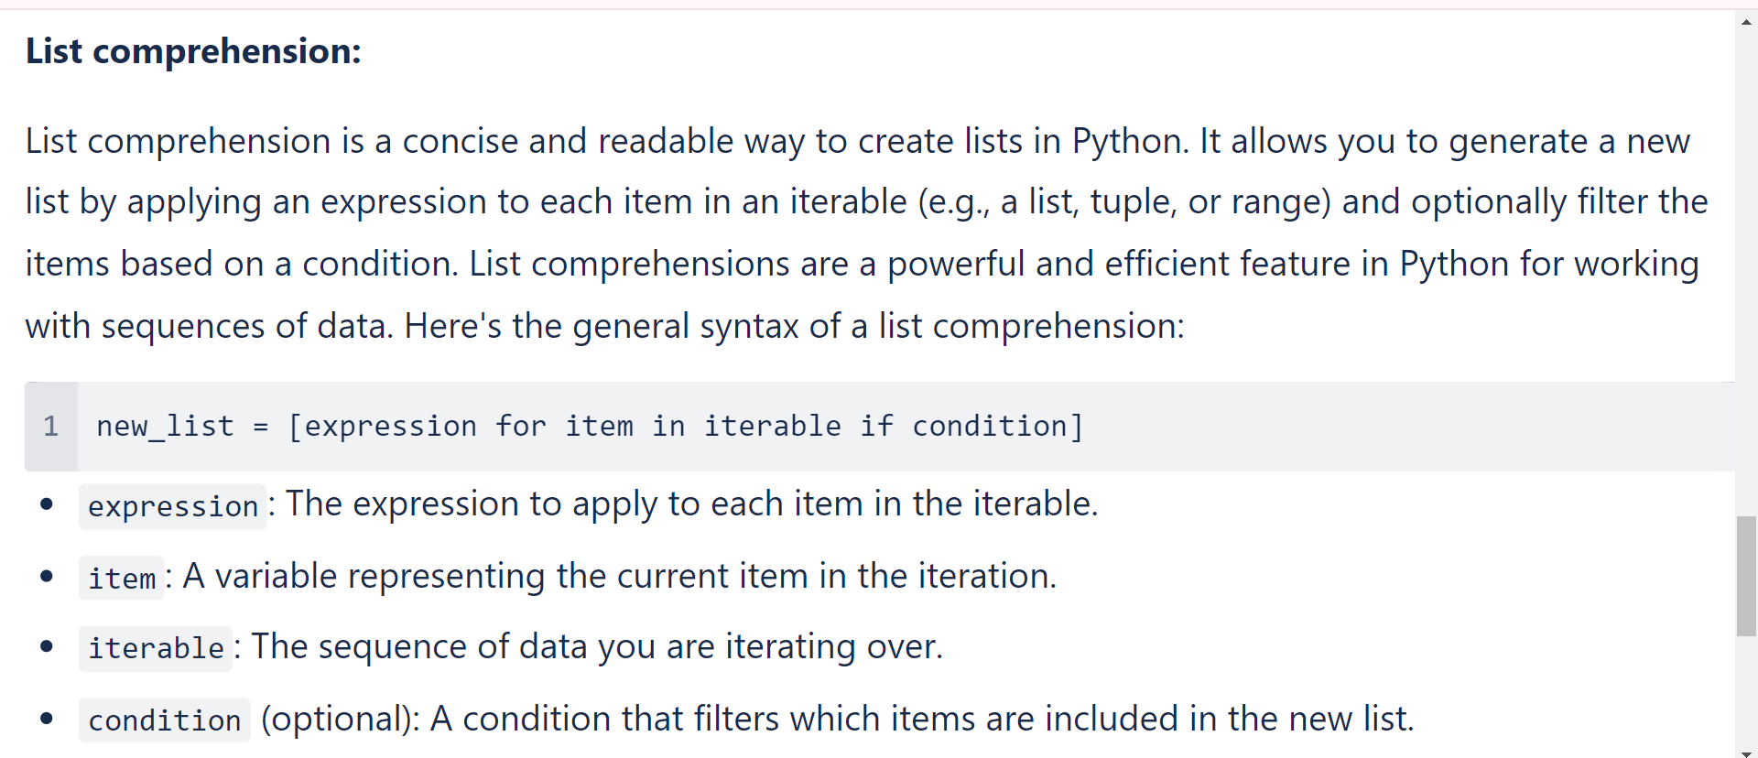

**Examples:**

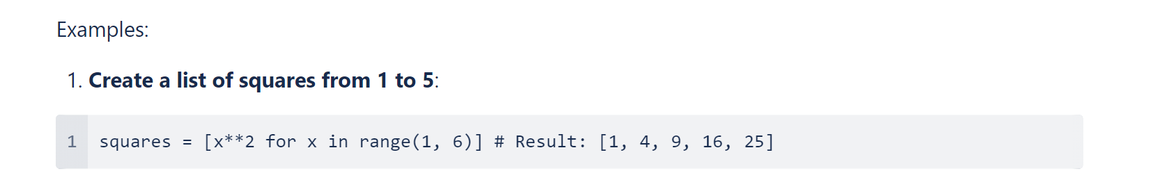

**Example-02**

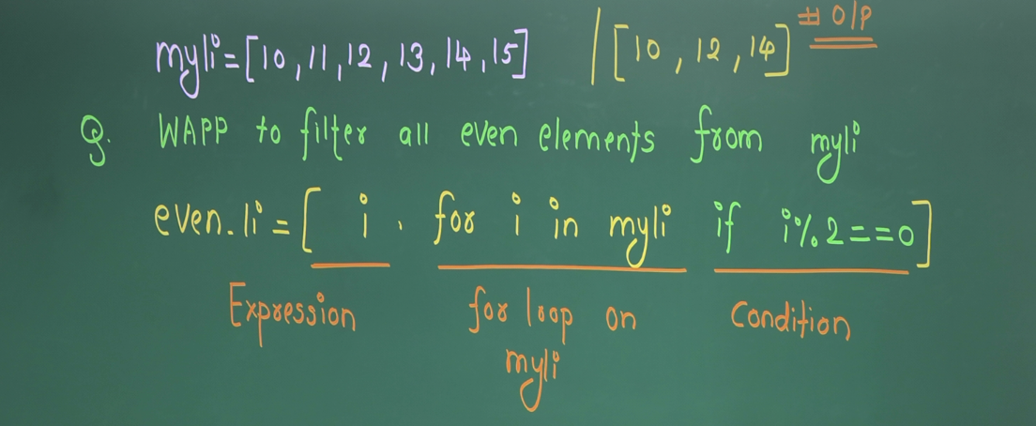

**Example-03**

**Create a list of names that start with 'A'**:

names = ["Alice", "Bob", "Charlie", "David", "Eve"]

a_names = [name for name in names if name[0] == 'A']

# Result: ['Alice']

**Example-04**

Fruits= ["apple", "banana", "cherry", "apple"]

unique_lengths = {len(word) for word in Fruits}

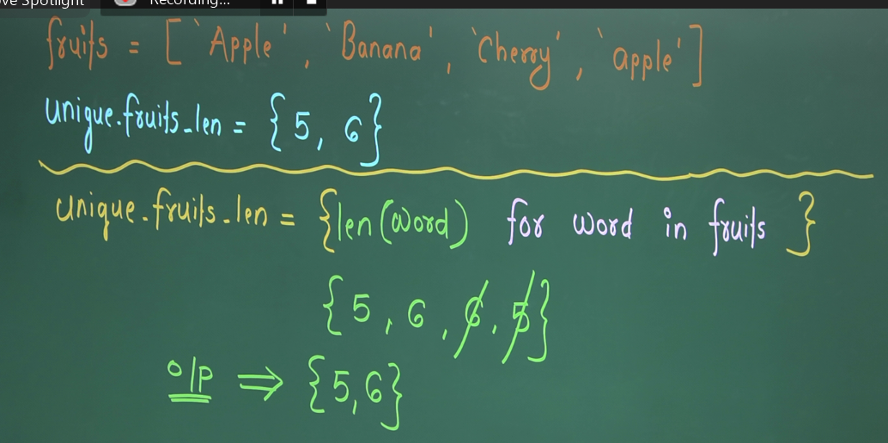

**Example-5**

**Creates a list of words with at least one vowel**

**Solution:**

vowels = ['a', 'e', 'i', 'o', 'u']

words = ["python", "programming", "language"]

filtered_words = [word for word in words if (char in vowels for char in word)]

**Example-6**

